Que 1 →
● Install Kubernetes cluster on CentOS 7 machine with kubeadm way. Also, install calico as CNI and check if all the worker nodes are in ready state. Also install
bash completion for kubectl.

Calico is a widely used Container Network Interface (CNI) plugin for Kubernetes that provides high-performance networking and advanced network security. It supports both BGP and VXLAN for routing, making it scalable for large clusters, and integrates seamlessly with Kubernetes NetworkPolicy for fine-grained traffic control between pods and namespaces.
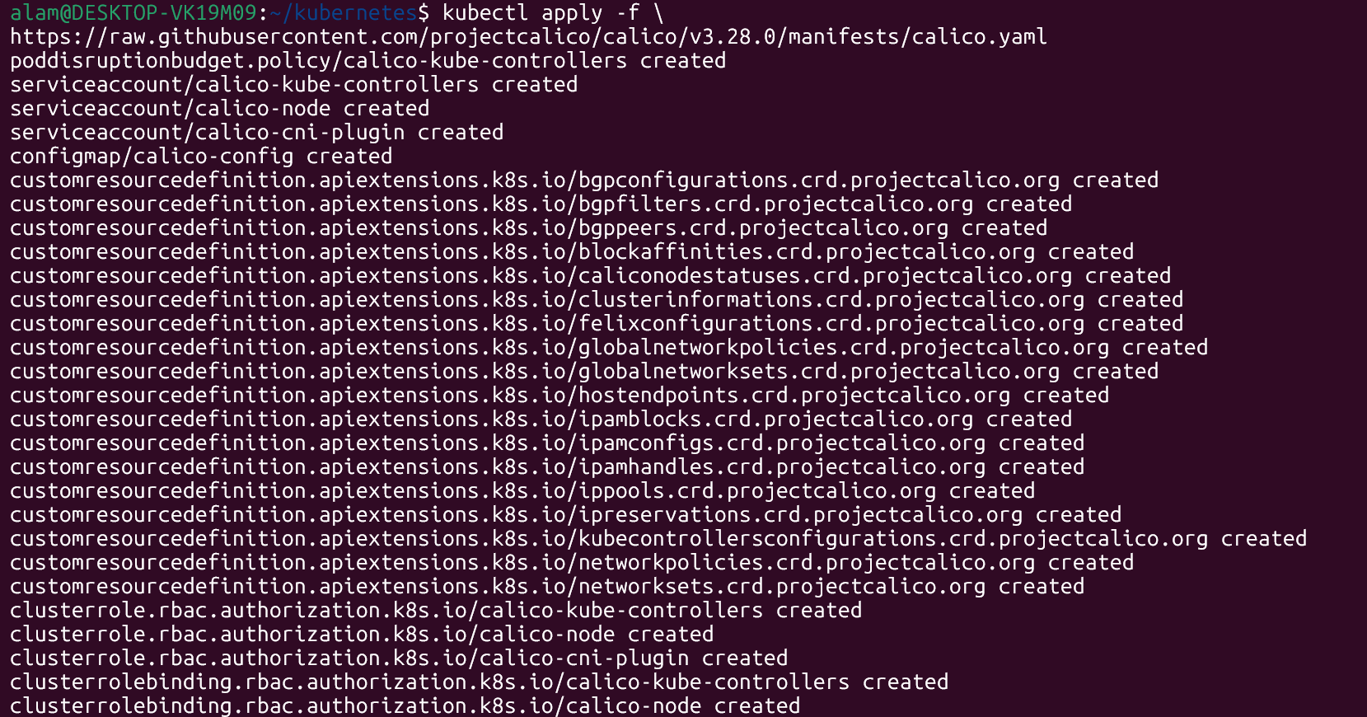

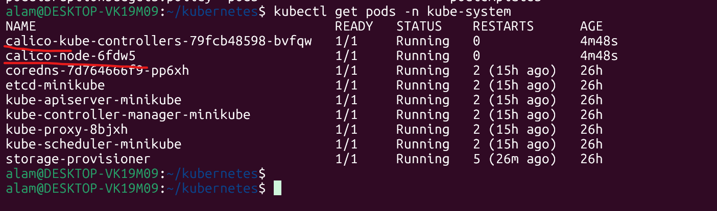

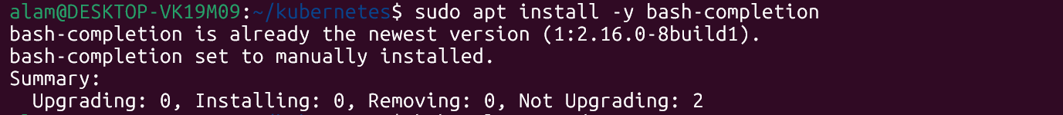

==================================================================================

Que 2 →
● Check the pod in all namespace with kubectl command and check the status of all the pods.
# kubectl get pods --all-namespaces
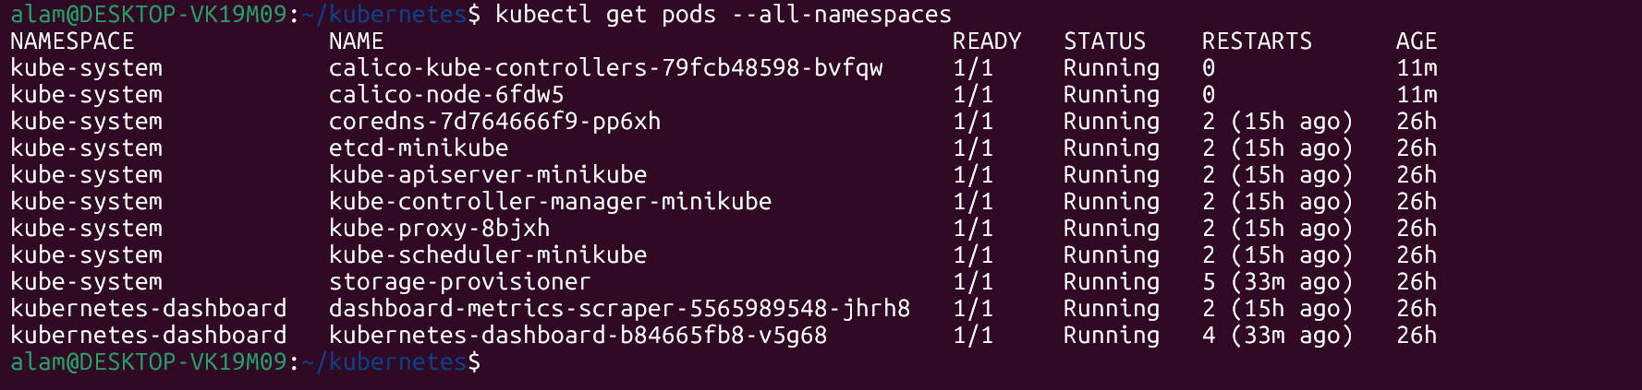

==================================================================================

Que 3 →
● Create one nginx pod on your Kubernetes cluster and then delete the same.
# kubectl run nginx --image=nginx ---nginx pod will be created
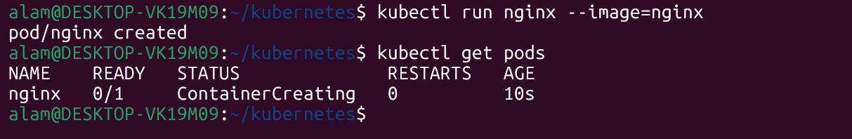

# kubectl delete pods nginx --- delete the pods

==================================================================================

Que 4 →
● Create a yaml file for replicationcontroller and replicaset. Update the name from metadata and add yourname_rc and yourname_rs to both objects respectively. Once files are ready, deploy the objects in your K8S cluster with kubectl command.
# kubectl apply -f alam_rc.yaml
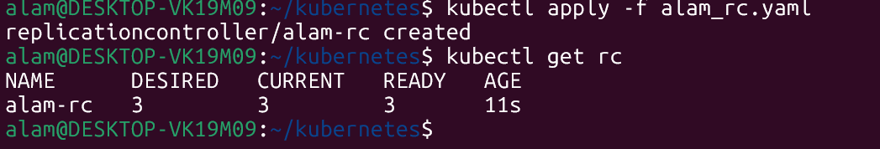

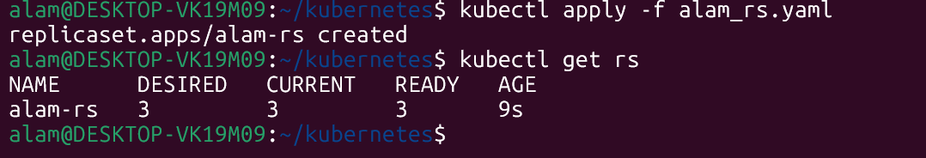

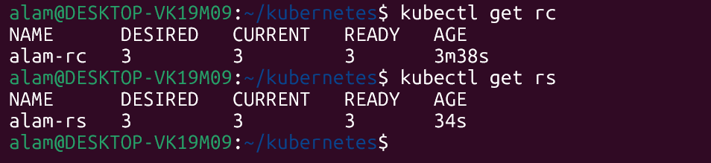

Que 5 →
● Clone https://github.com/zembutsu/docker-sample-nginx.git on your local system.

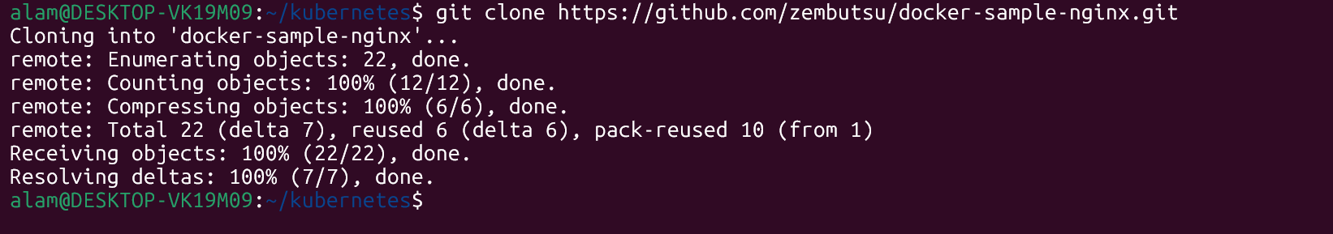

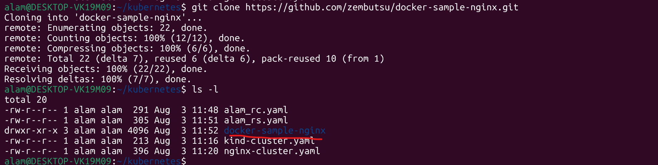

● Initialize one repo on your local system named Cloudethix-nginix-yourname and then copy all the content from cloned repo to your local repo.

# Cloudethix-nginix-alam
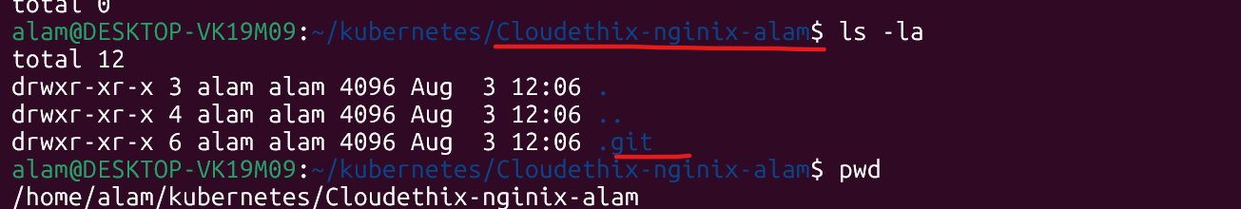

Cloned repo data
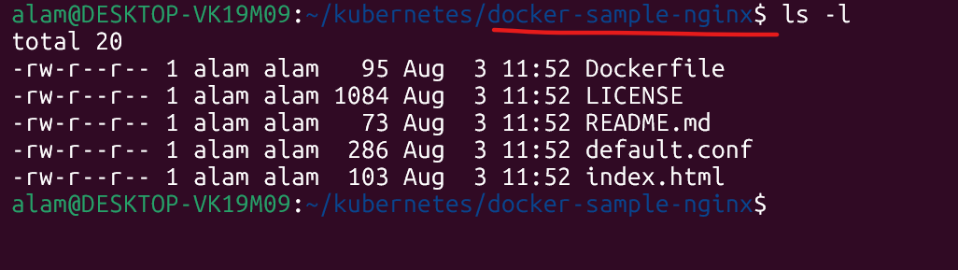

Copied data at Cloudethix-nginix-alam at mine local repo
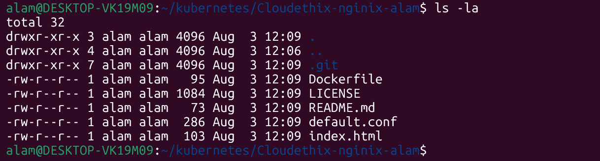

● Update the index.html and add the name CloudEthiX along with Hostname. Commit the change to your local repository. Then create and push the code from the local repository to your remote repository named Cloudethix-nginix-yourname under master branch.

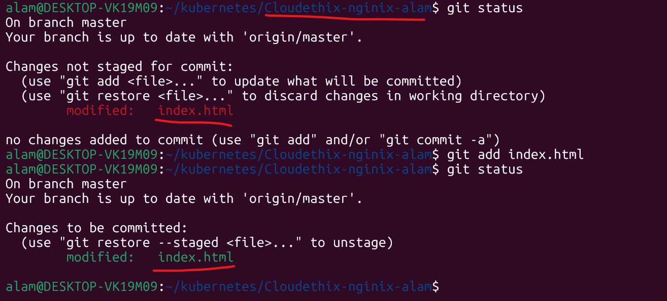

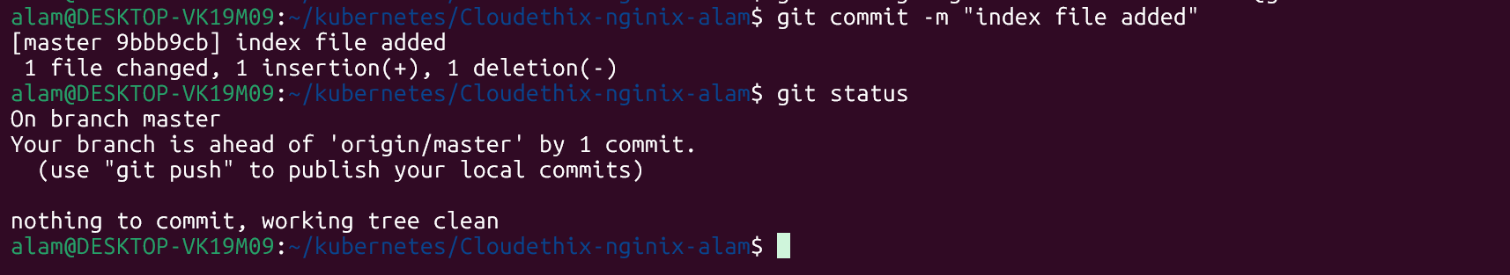

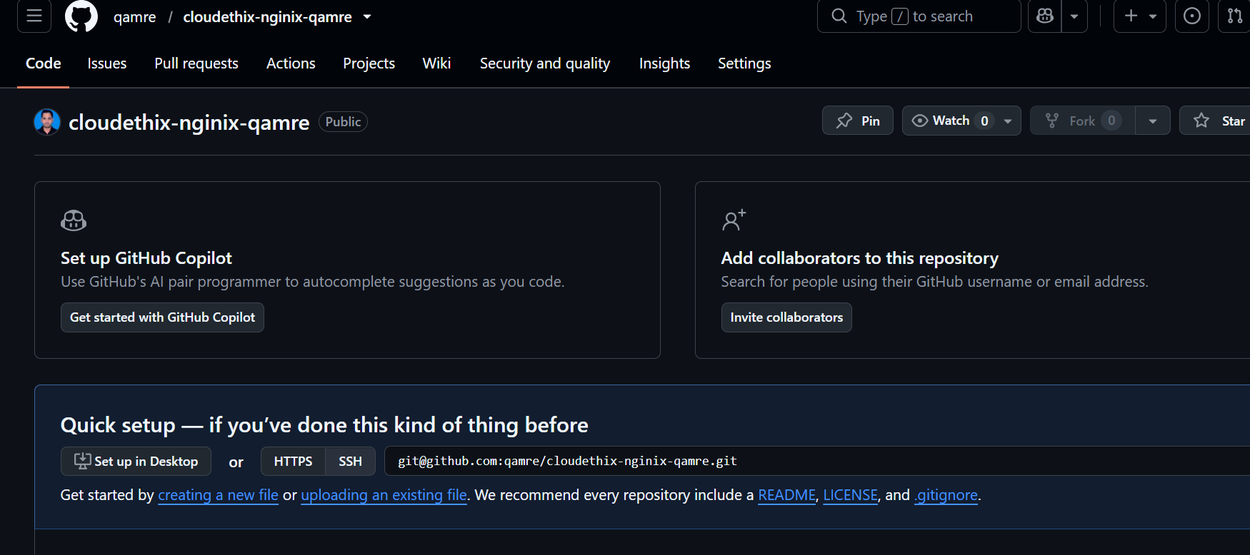

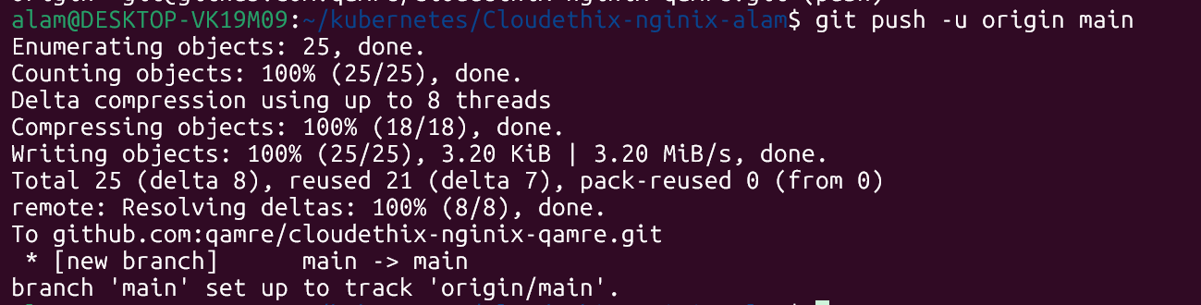

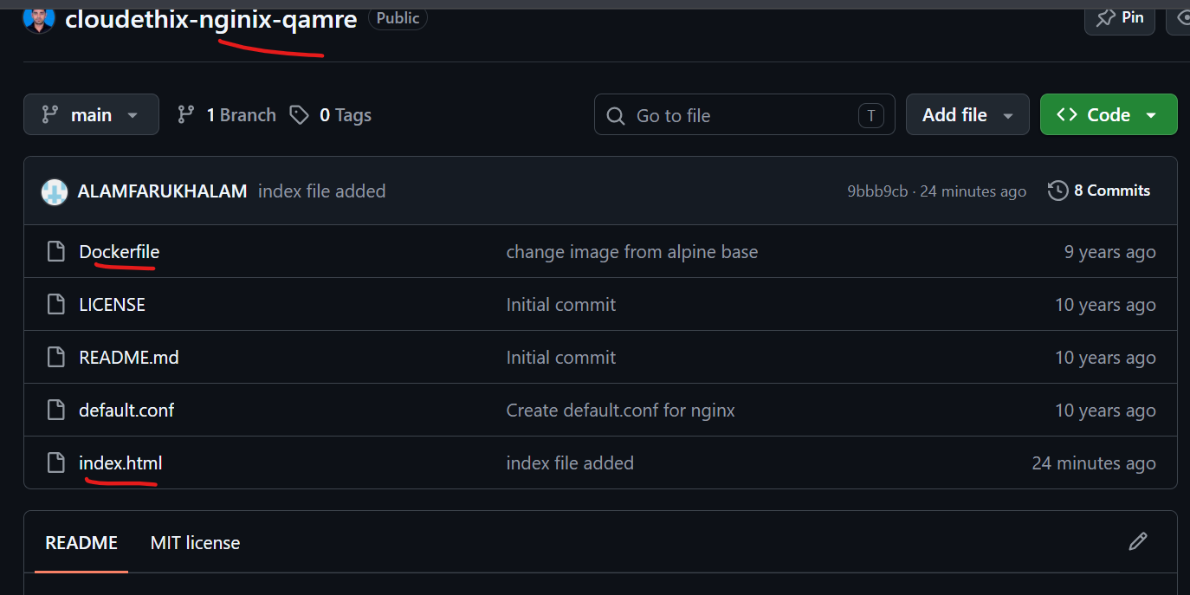

● Once code is pushed, create a Docker hub public repository named
Cloudethix-nginix-yourname.

Cloudethix-nginix-qamre
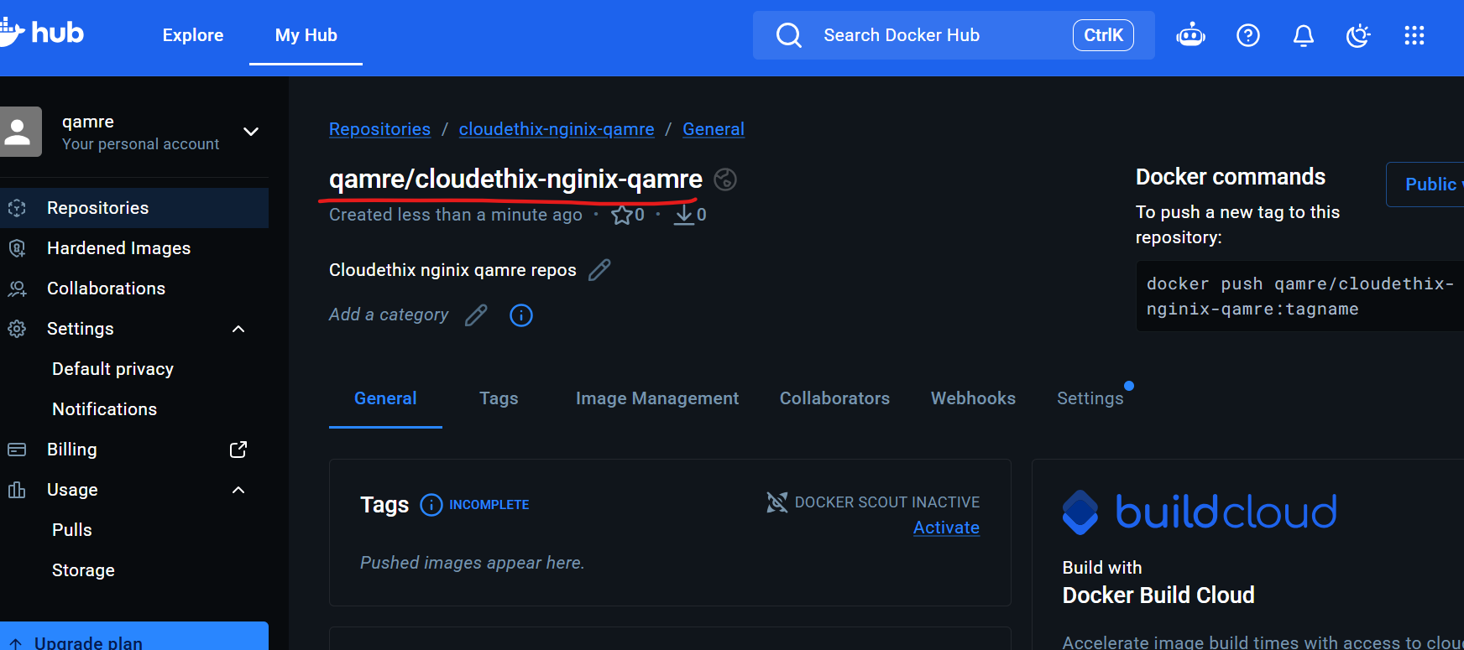

● Then build the docker image out of the dockerfile. Once an image is built, tag the imageand push that image to the docker hub repo you created.

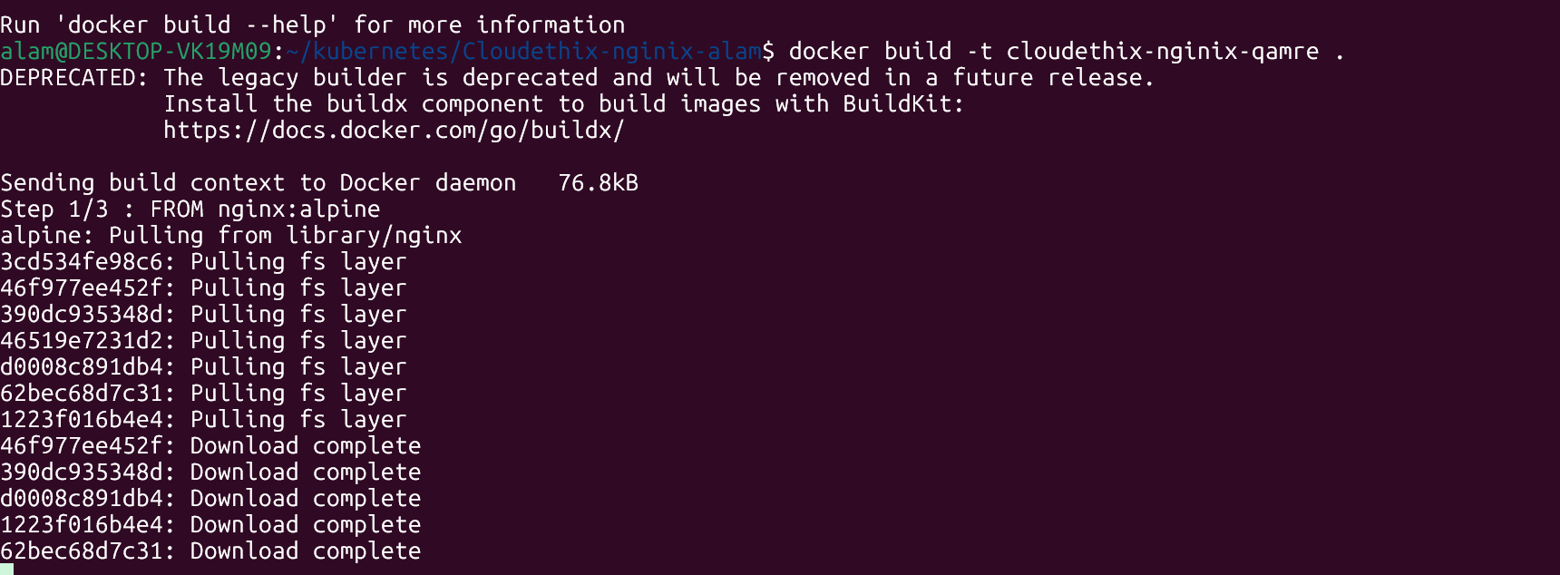

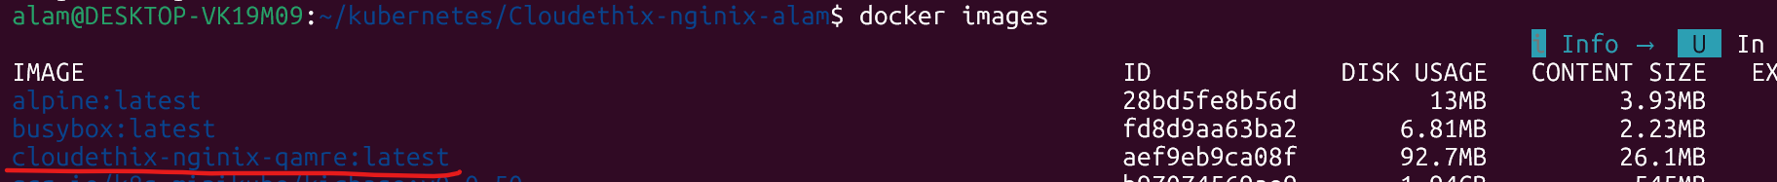

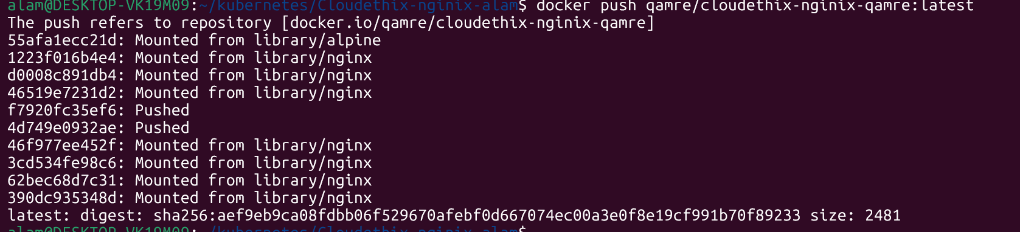

Finale result
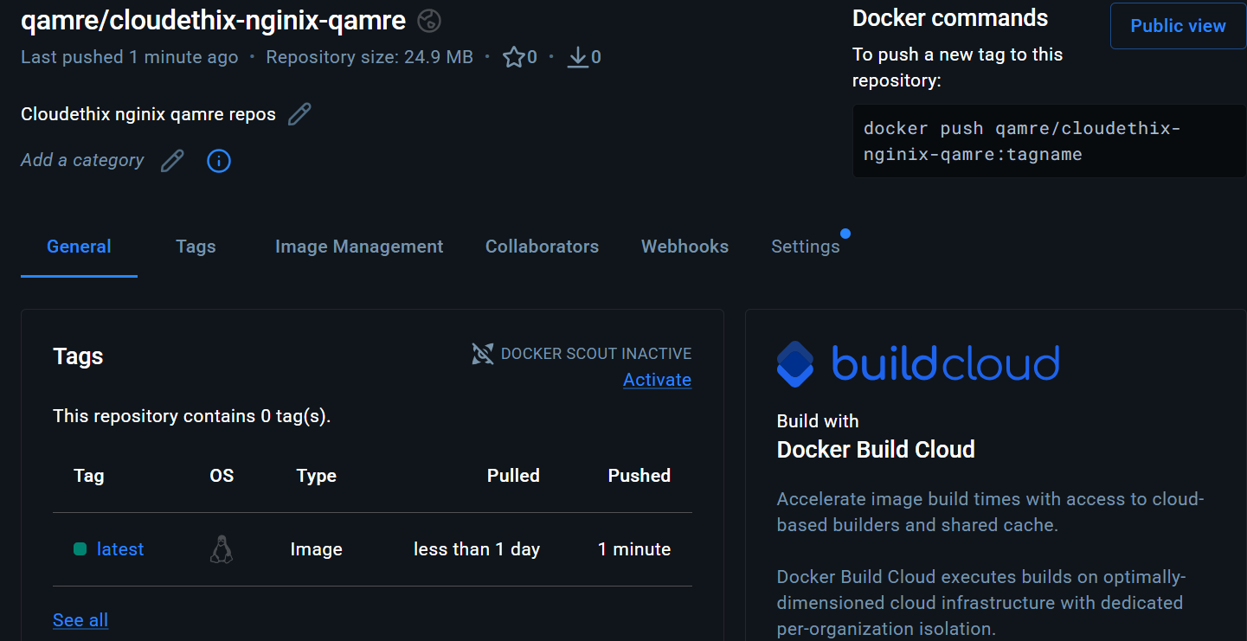

● Create a deployment.yaml file with 2 replications in cloudethix_yourname Namespace and use the container image that you have pushed to your docker hub repo. Once a file is created, run the deployment in k8s cluster.

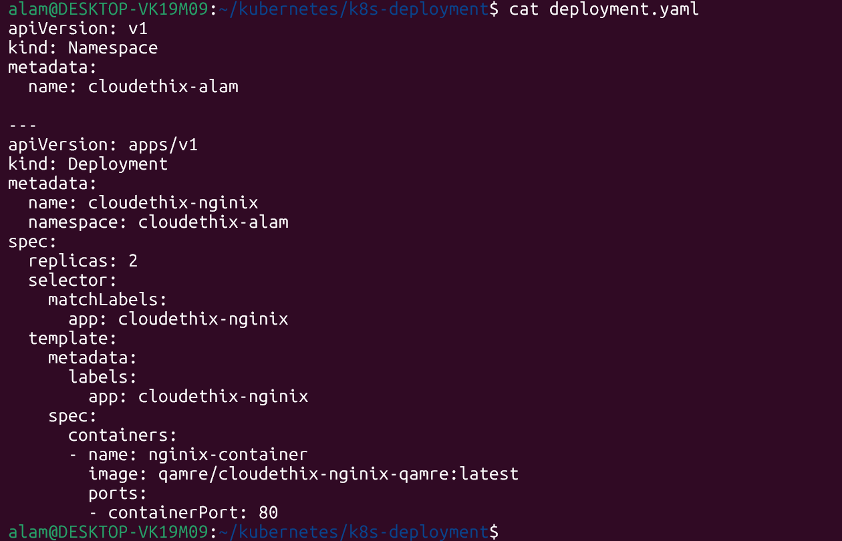

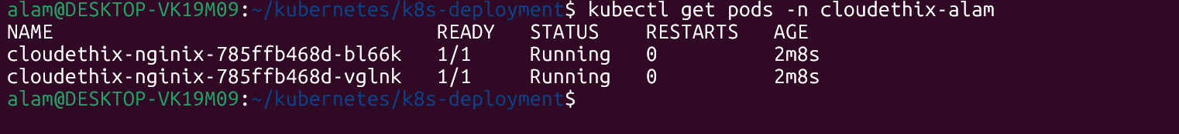

● Please prepare a document along with the snap and share it across.

